Date: 13.9.23 Ind / T / TA / Peer
LO: To find out about the life and work of Roald Dahl
SC:
I can say who Roald Dahl is
I can say what I like about his work
I can retell a story by Roald Dahl
After being asked if they had heard of Roald Dahl the children found out about what job he did and why he was famous. They looked at some of the books he had written and talked about which ones they knew. As a class we then listened to a retelling of his short story ‘The Enormous Crocodile’. We discussed whether we had enjoyed the story and which parts we liked the best. All the children were able to contribute to discussion with partner talk and feedback to the class with ideas and opinions.
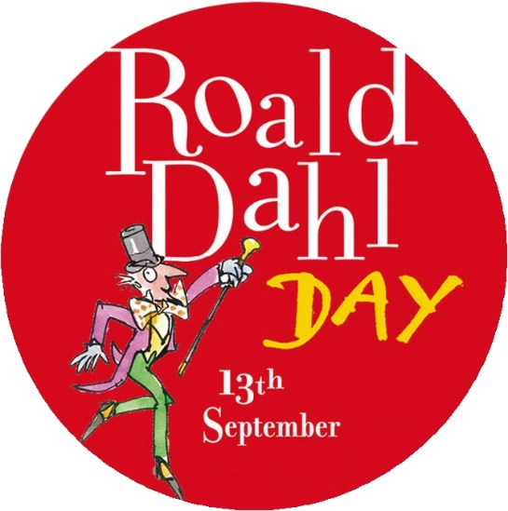
Things we found out
- Roald Dahl was born on 13 September 1916, in Llandaff, Cardiff. His parents were Norwegian.
- Roald Dahl did not start writing for children until he had children of his own. His first ever children’s book published was in 1943 entitled ‘The Gremlins’. It is said that Roald was never very fond of this book.
- He LOVED chocolate, but not chocolate cake or ice cream! Maybe this is why he chose to write about Willy Wonka’s Chocolate Factory!
- He always wrote his stories in pencil on yellow paper. He would write in a small hut in his garden.
- Roald was a hurricane fighter pilot during WW2.
- Roald Dahl died on 23 November 1990 and is buried in St Peter and Paul’s Church in Great Missenden.
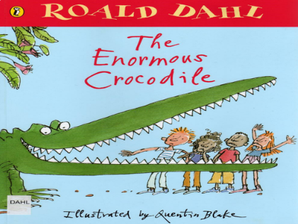
Team AC gave the story a thumbs up! We enjoyed the different animal characters and how they saved the children and spoilt the crocodiles plans when he pretended to be different objects. We tried to remember all the objects in order! We will always make sure we check the playground as we wouldn’t want him to come to Park Street and eat us up!

