The Very Hungry Caterpillar Summer term week 1. Choose from the tasks below.
Make a symmetrical butterfly | 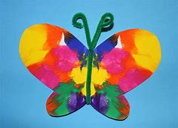
Make a collage butterfly | 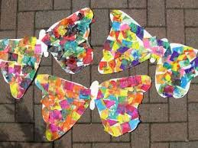
Make a list of foods that the caterpillar eats in the story.  Or make up your own list of foods that the caterpillar could eat.  Such as:- 1 mango  2 grapes  3 packets of crisps  Can you draw pictures to go with your list to make a zigzag book. | 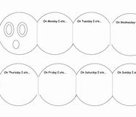  You can make a book by folding half a sheet of A4 paper.
Make a butterfly using natural materials. | 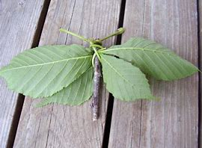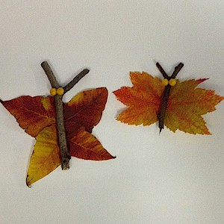
Add together foods that the caterpillar could eat. Such as:-  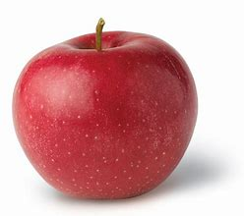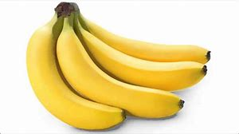 | Write the number sentence to go with your foods. 2 + 4 = 6  You could use real foods or draw pictures.

