Name:

Autumn 2 – Week 1

Literacy homework

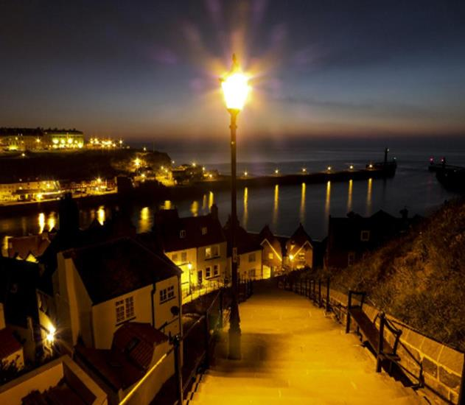
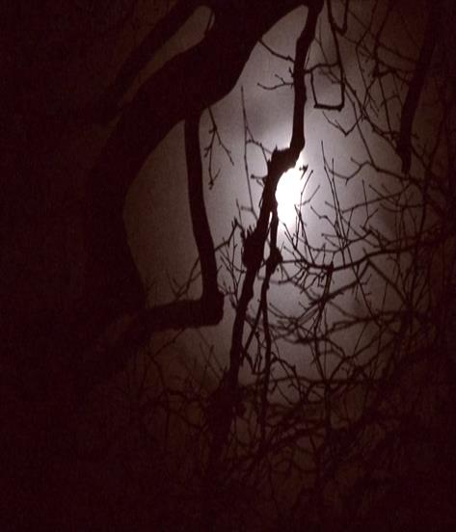

The moon twinkled brightly through the cheerful trees. I skipped merrily up the steep steps after the dog.

