

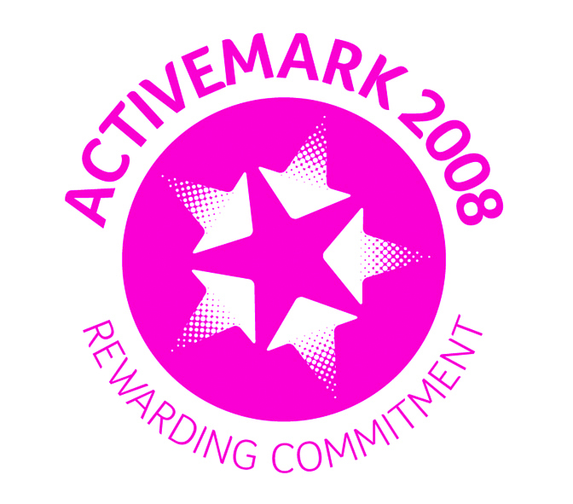

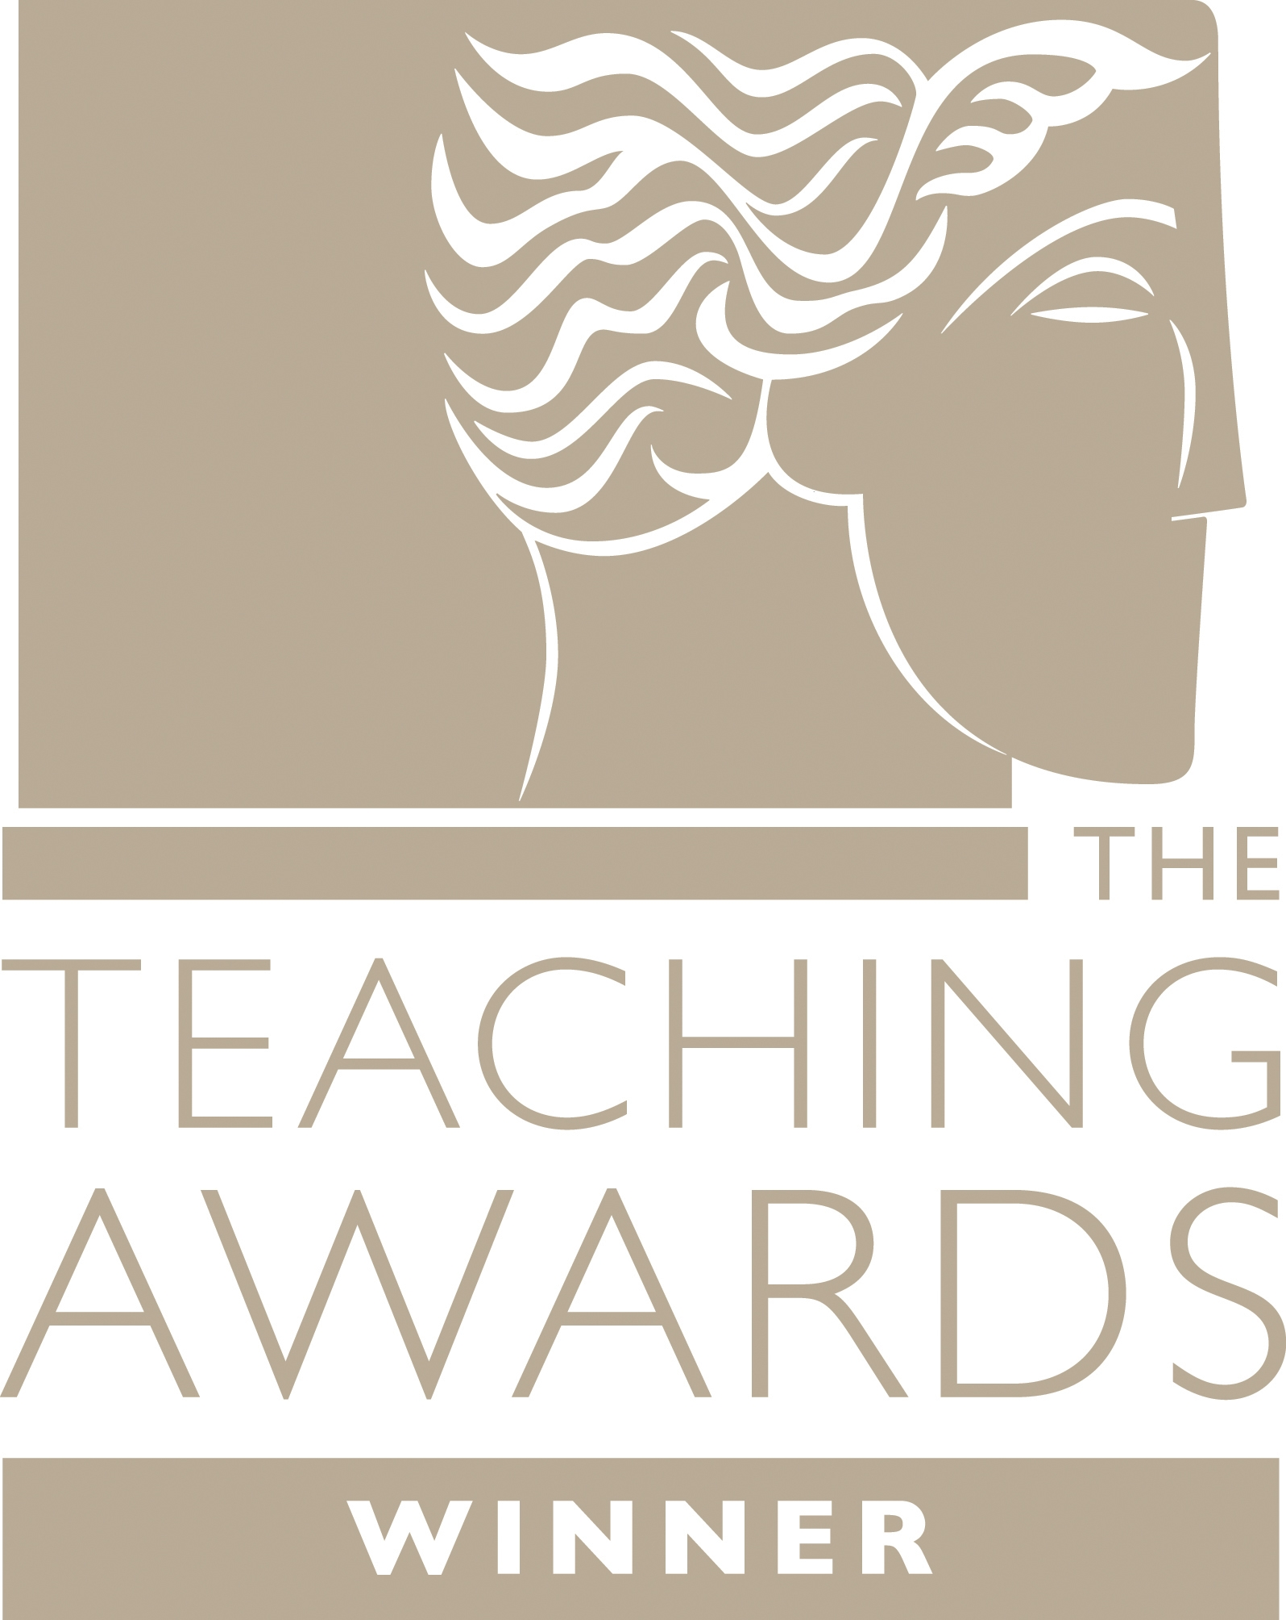





Wombwell Park Street Primary School
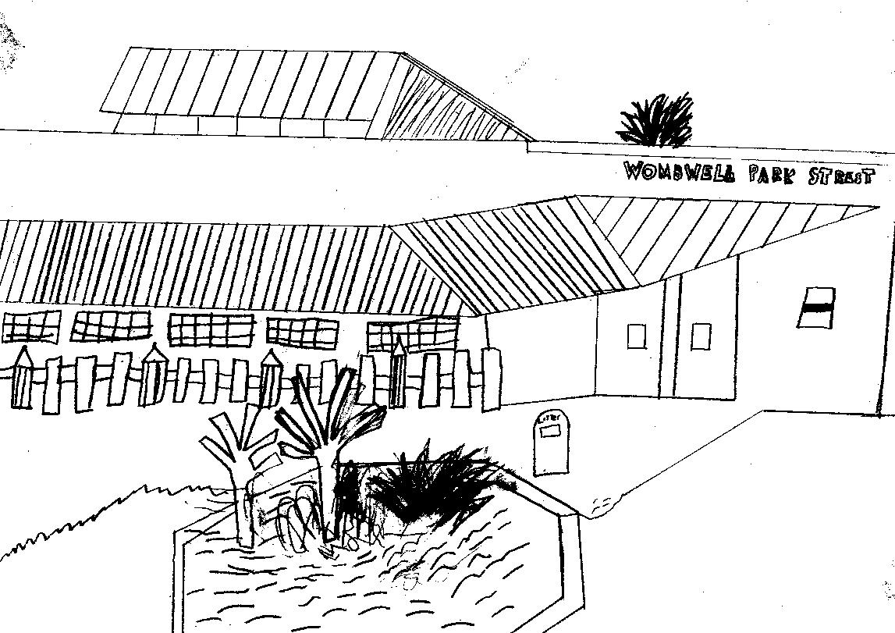
Park Street

Wombwell
Barnsley
S73 0HS
Tel: 01226 752029
Email: parkstreet@ecmtrust.co.uk
Website: www.wombwellparkstreetprimary.co.uk

Executive Headteacher: Mrs G Foster-Wilson
Head of School: Mrs C Lawson
Every Child Matters Academy Trust
Deputy Head of School: Mrs L Longden

________________________________________________________________________________________

Monday 27th March 2017

Dear Parent/Carer,

This half term’s Personal Learning and Thinking Skill is EFFECTIVE PARTICIPATION. We feel being confident enough to join in activities, share ideas and contribute proactively to group work are all important skills. We will be working hard over the next few weeks to provide pupils with opportunities to develop these skills further.

Last week in school we held our annual Science week, as did many schools around the country as part of National Science Week. The focus this year was all about exploring changes. We would like as many of our children as possible to take part in the National Science Week Poster Competition. Further details are included on the reverse of this letter along with a message from PAT THE EFFECTIVE PARTICIPATOR one of our PLT super heroes.



Yours sincerely,

Mrs Louise Longden
Deputy Headteacher

Poster competition instructions for Reception pupils.

Boys and girls it would be brilliant if you could get involved and join in with this poster competition. Good luck and get cracking!
From Pat

INSTRUCTIONS

Think about different types of changes in the natural world around you.
For example:
- Leaves on trees changing colour
- Weather changing from rainy to sunny
- Daytime changing into night

RULES FOR THE POSTER

- The poster can be on A4 or A3 paper
- You can draw, paint or stick things on
- It must be as colourful and creative as possible

When you have finished

- Return it to school for Thursday 6th of April
- All children who enter will receive a certificate from Pat
- There will be a competition in each class and the winning entry will be sent off and entered into the British Science Week national competition. Unfortunately only 10 entries are allowed per school.



