Y5 COMPREHENSION

How did Harry Patch become an unlikely WW1 hero?

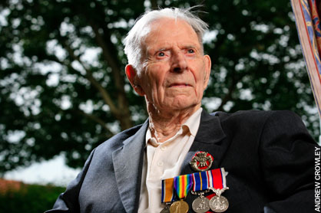
How did Harry Patch become an unlikely hero of WW1?

Section One: Harry's story

Harry Patch was an ordinary soldier of the First World War. Like many who fought, he was conscripted (that means he was told that he had to join the army) and sent to the trenches of the Western Front, where he was wounded at the Battle of Passchendaele in 1917. Passchendaele (which is a really hard word to spell) is in Belgium, very close to the city of Ypres. The Battle of Passchendaele is also known as the Third Battle of Ypres.
Unlike many, Harry lived on until the age of 111, by which time he had become the last British survivor of the World War One trenches.
Harry did not like to talk about his experiences in the war. He certainly didn’t consider himself to be anyone special or important. However, when he died in 2009, over 1,000 people, including important people from around the world, attended his funeral.
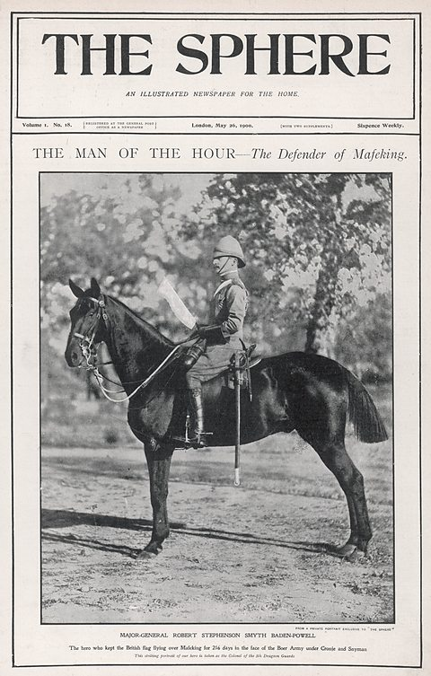
When war broke out, it wasn’t ordinary ‘Tommies’ who were seen as seen as ‘heroes-in-waiting.’ Instead it was a very different type of soldier who had already captured the public imagination.

Section Two: Men of their time
When the war started in 1914, the public held certain commanders and generals of the British Army in very high esteem!

The valiant defender – Robert Baden Powell
Robert Baden-Powell was a commander of an army base (known as a ‘garrison’) in a town called Mafeking in South Africa. During a war fought against the South African people in 1899 (known as the Boer War), Robert Baden-Powell and his men successfully defended their garrison for 217 days against an enemy siege. Stories of his exploits were reported back at home and made him famous. Baden-Powell later founded the scouting movement, based on his experiences in South Africa.

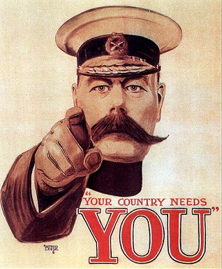
The charismatic leader – Lord Kitchener
At the beginning of the First World War, Lord Herbert Horatio Kitchener was already famous for leading British forces to a famous victory in the African country of Sudan in 1898. As Secretary of State for war he used his fame and face to front a recruitment campaign to swell the ranks of the armed forces. Thousands would have recognised him, and thousands answered his call.
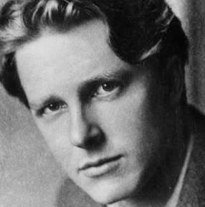

The sacrificial hero – Rupert Brooke
Rupert Brooke’s poem 'The Soldier' was published in January 1915, with World War One just a few months old. Its famous lines - ‘If I should die, think only this of me: That there's some corner of a foreign field, that is for ever England’ - embodied a noble and classical ideal of sacrifice in war.

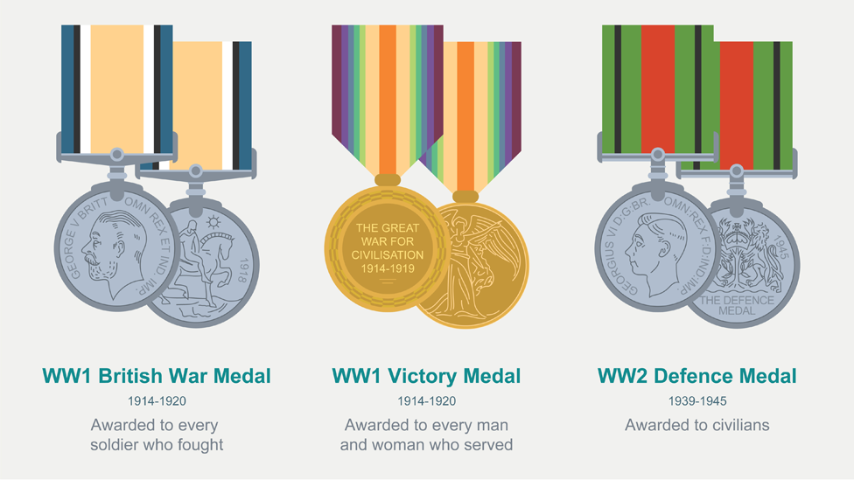
Section Three: Harry Patch's medals
The medals awarded to Harry Patch - from service in World War One to a fireman during the Blitz in World War Two - tell the story of how, over time, the British Army started to recognise the bravery of more and more people and not just the Officers and Generals.

Section Four: The new WW1 hero

Fragile heroes
In the last few decades we have found out more about individuals like Harry Patch, who didn’t necessarily do heroic or exceptional deeds, but just endured tremendous suffering – and never once complained about it.
‘Birdsong’, is the title of a very famous book written by an author called Sebastian Faulks. It tells the story of two men who worked as tunnelers during WW1. They dug tunnels beneath the trenches in an attempt to attack the Germans in a different (more sneaky) way. ‘Birdsong’ focuses on the emotional impact the war had on many of the soldiers who fought in it. When you are older you should read this book. It has one of the best endings of any book ever written.

New perspectives
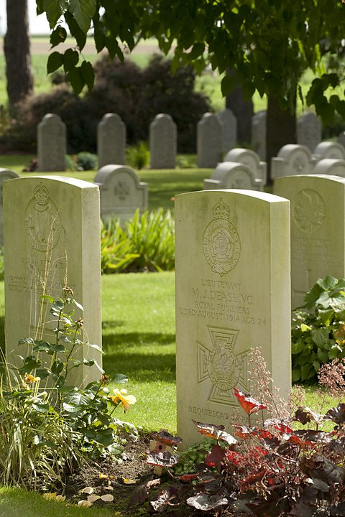
The 100 year anniversary (also known as a centenary) of the outbreak of the First World War in 2014 has provided an opportunity to rethink the way the war is remembered. Storytellers have searched for new perspectives (this means, a new way of thinking about something) and new kinds of heroes. BBC television drama ‘The Crimson Field’ views the battle in the trenches through the experiences of women working in the hospitals just behind the line. Their sacrifice and service is explored alongside that of the soldiers they treat.

Section Five: Who are the heroes of WW1?
World War One presented many opportunities for individuals to show different kinds heroism. Who should we remember as a World War One hero?

Professor Mary Beard, historian
The idea of “heroism” was invented by the ancient Greeks – who found it as tricky an idea as we do. Could anyone become a hero? Did you have to be long dead to be a hero? Could women be heroes? Was heroism seen only in battle, or in everyday life too? Were there heroes among the enemy? This question is raised in a famous epic poem called ‘The Iliad’, written almost 3,000 years ago by a famous poet called Homer. The Iliad is about the first Great War of history, between the Greeks and the Trojans.
The Iliad was in my mind when I visited St Symphorien Cemetery – the joint Commonwealth and German burial ground in Belgium.
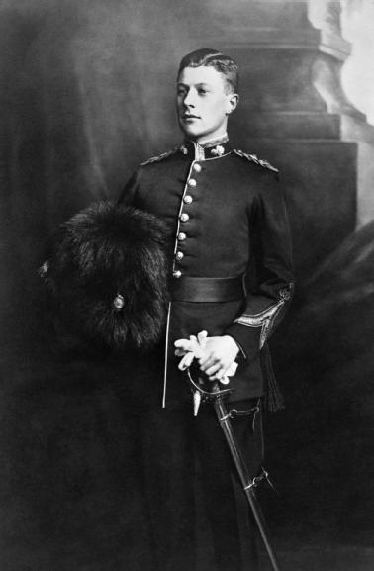
It contains the grave of the first man to be awarded a Victoria Cross in World War One, Lieutenant Maurice Dease; and also the grave of a German soldier, Musketeer Oskar Neimeyer, who died on the same day, after extraordinary feats of bravery. I couldn’t help thinking that – whatever their views on the war in which they served and died - these were heroes, both of them; not to mention, as I feel sure, the sons of heroic mothers.
(Maurice Dease, pictured left, was killed in the first year of the War – 1914 – at the age of 24).

Dr Stephen Clarke, The Royal British Legion
My selection is a group of men who took part in the war - stretcher bearers. I come from New Zealand where a stretcher bearer called John Simpson Kirkpatrick and his donkey Duffy are part of the Anzac legend after they made many fearless rescues at Gallipoli. He was killed by machine gun fire.
I have a personal link to stretcher bearers as my great grandfather Sergeant Edward Dillon was in the field ambulance. A diary entry he wrote on 15 September, 1916, shows how he and his unit displayed heroic qualities at The Somme: ‘I got our patient in a shell hole and started to dress the wounds... We just started and Fritz must have spotted us for he played on his machine gun in good style for about twenty minutes, we had our noses well in the mud… The remainder of the squad still searched for wounded soldiers.’
I think the compassion and comradeship that these men showed makes them as much heroes as their bravery under fire does.

Professor Alison Fell, historian
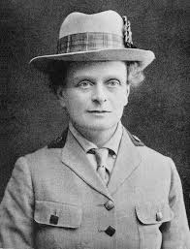
Dr Elsie Inglis was a Scottish doctor. In 1914, aged 49 and with 16 years of hospital experience, she offered her services to the Royal Army Medical Corps (RAMC), but was turned down because the Government didn’t think that women should be involved on the front line. (In fact the War Office actually told her to ‘go home and sit still’).
However, like another famous nurse - Mary Seacole - Inglis raised the money herself and set up the Scottish Women's Hospitals for Foreign Service, which ran field hospitals in France, Serbia, Turkey and Russia. They performed extraordinarily valuable work in some of the most difficult circumstances. Inglis was fighting battles on more than one front during the war: she was fighting to save the lives threatened by wounds and disease, and to prove women doctors could do wartime medical work as well as men.

Now answer these questions:
1 During which battle of WW1 was Harry Patch wounded? (Section One) ___________________________________________________________________
2 The Battle of Passchendaele is also known as what? (Section One) ___________________________________________________________________
3 Why do you think lots of people from around the world attended Harry’s funeral in 2009? (Section One) _________________________________________________________________________________________________________________________________________________________________________________________________________
4 Which three word phrase at the end of Section One means a person who is expected to behave like a hero in the very near future? ___________________________________________________________________
5 What does it mean if you hold someone in high esteem? (Section Two) ______________________________________________________________________________________________________________________________________
6 What did Robert Baden-Powell do in South Africa in 1899 that made him very famous back home in Britain? (Section Two) ______________________________________________________________________________________________________________________________________
7 What were the posters with Lord Kitchener’s face on used for? (Section Two) ______________________________________________________________________________________________________________________________________
8 To which group of people was the WW2 Defence Medal awarded? (Section Three) ___________________________________________________________________
9 A 100 year anniversary is also known as what? (Section Four) ___________________________________________________________________
10 Which group of people does Dr Stephen Clarke think are heroes of WW1? (Section 5) ___________________________________________________________________
11 Why can Elsie Inglis be compared to another famous nurse, Mary Seacole? (Section Five) ____________________________________________________________________________________________________________________________________________________________________________________________________________________________________________________________________________

