

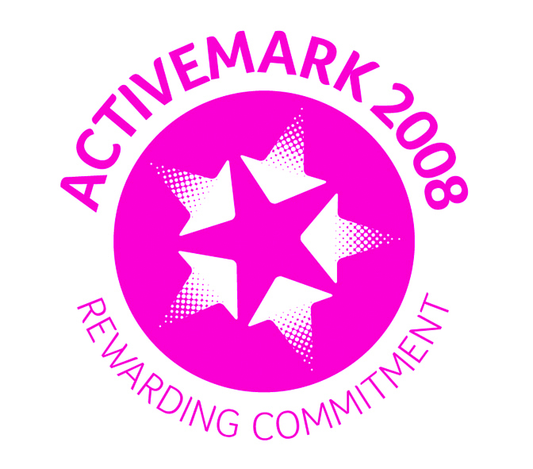
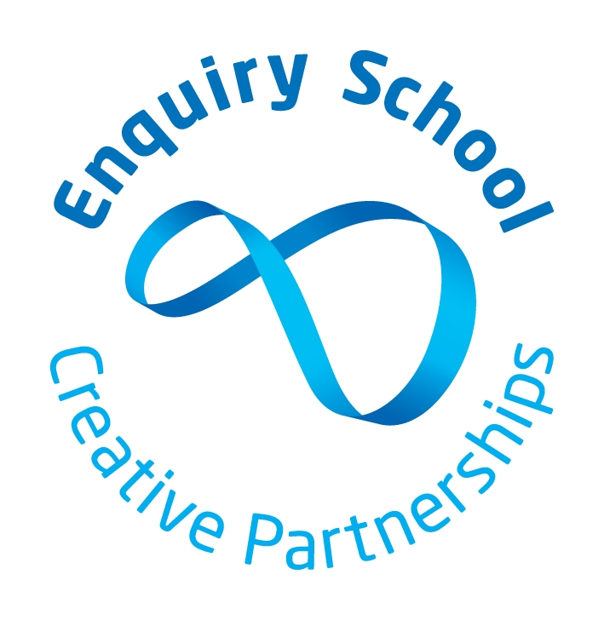
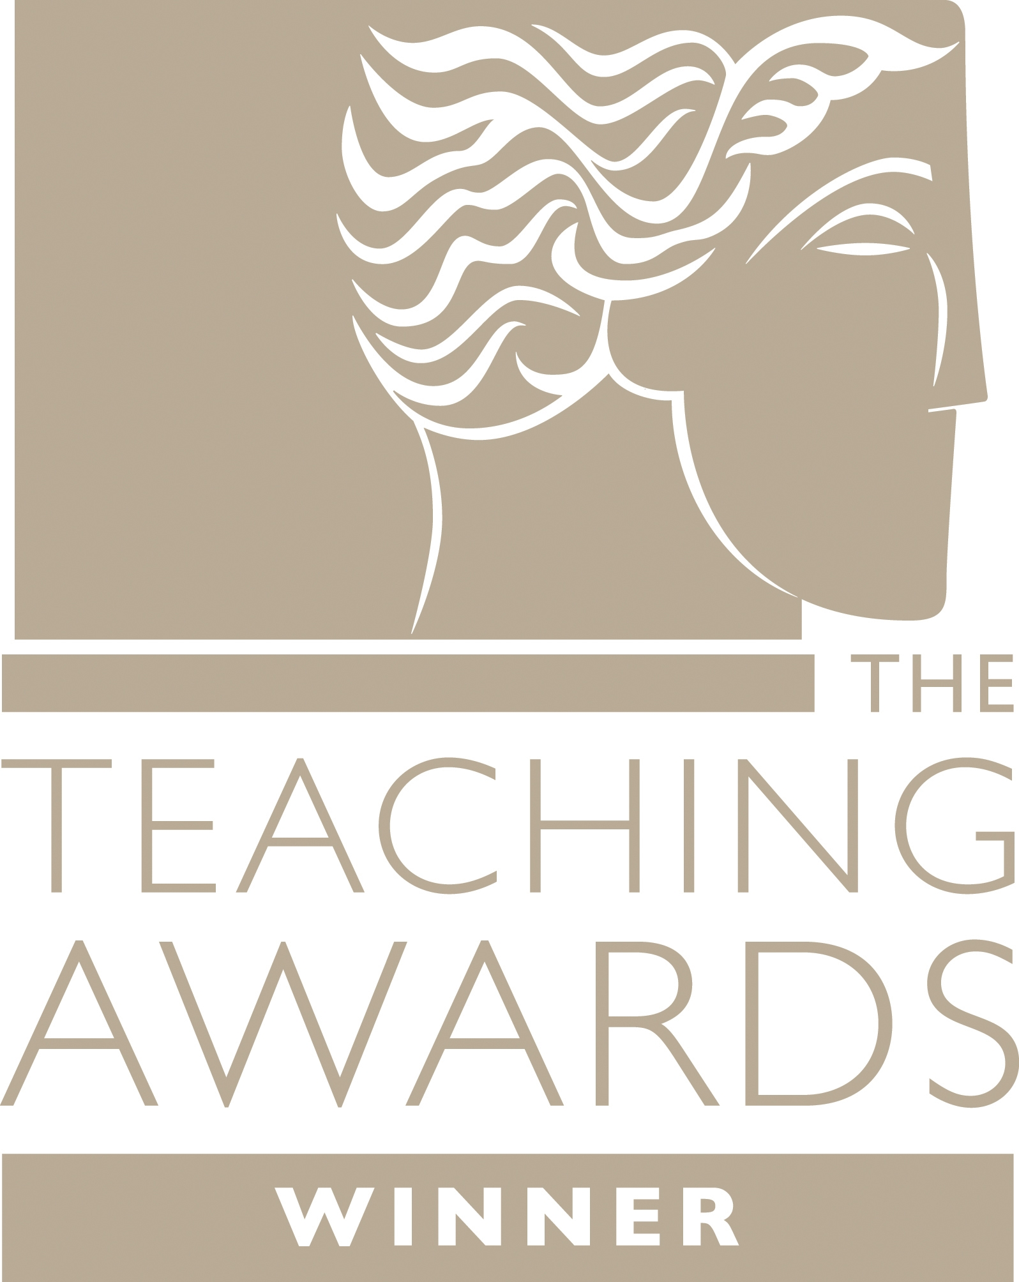
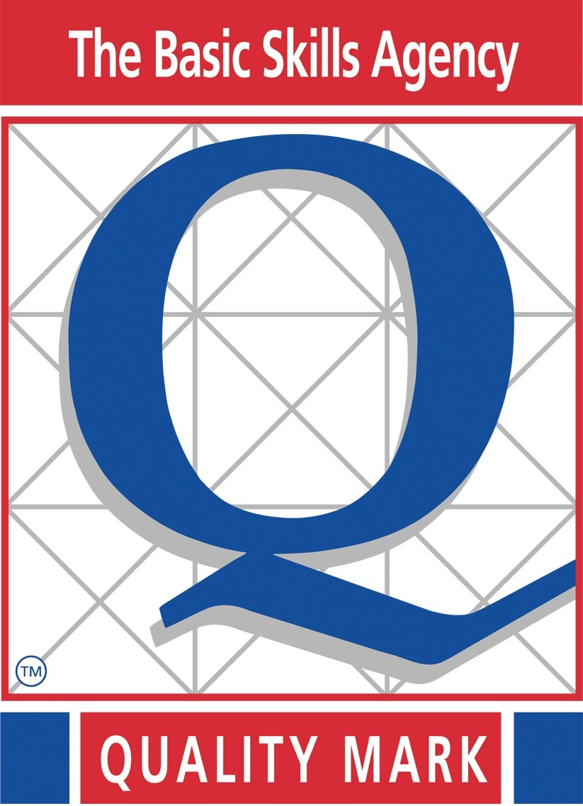
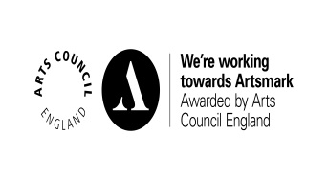
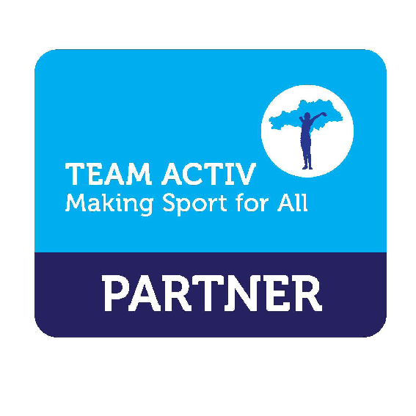


Wombwell Park Street Primary School
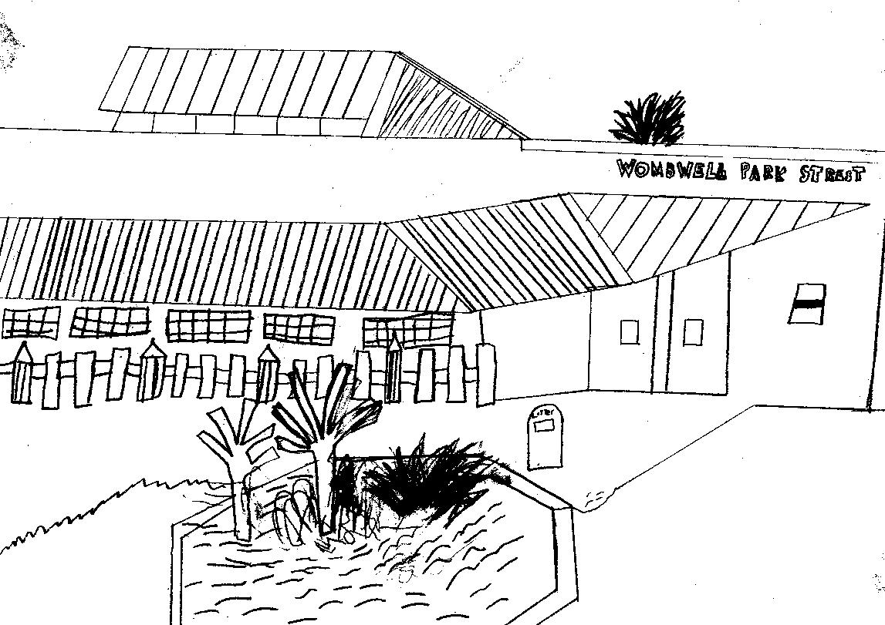
Park Street

Wombwell
Barnsley
S73 0HS
Tel: 01226 752029
Email: parkstreet@ecmtrust.co.uk
Website: www.wombwellparkstreetprimary.co.uk

Executive Headteacher: Mrs G Foster-Wilson
Head of School: Mrs C Lawson
Every Child Matters Academy Trust
Deputy Head of School: Mrs L Longden

________________________________________________________________________________________

Monday 27th March 2017

Dear Parent/Carer,

This half term’s Personal Learning and Thinking Skill is EFFECTIVE PARTICIPATION. We feel being confident enough to join in activities, share ideas and contribute proactively to group work are all important skills. We will be working hard over the next few weeks to provide pupils with opportunities to develop these skills further.

Last week in school we held our annual Science week, as did many schools around the country as part of National Science Week. The focus this year was all about exploring changes. We would like as many of our children as possible to take part in the National Science Week Poster Competition. Further details are included on the reverse of this letter along with a message from PAT THE EFFECTIVE PARTICIPATOR one of our PLT super heroes.



Yours sincerely,

Mrs Louise Longden
Deputy Headteacher

Poster competition instructions for Key Stage 1 and 2.

Boys and girls here is your chance to effectively participate in THE NATIONAL SCIENCE WEEK POSTER COMPETITION Good luck and get cracking!
From Pat

Investigate or imagine the different types of changes occurring in science and the natural world around you. Choose a topic for your poster and do some research around the idea.

STEP ONE: RESEARCH YOUR POSTER
- What different types of change can we examine in nature?
- Carry out a science experiment and investigate the changes.
- How has our world changed over the years?
- Think about how you might change the world in the future

STEP TWO: MAKE YOUR POSTER

- The poster can be on A4 or A3 paper
- You can draw, paint or stick things on
- You can use pop up pictures, pull out tabs and labels.
- It must be as colourful and creative as possible

When you have finished

- Return it to school for Thursday 6th of April
- All children who enter will receive a certificate from Pat
- There will be a competition in each class and the winning entry will be sent off and entered into the British Science Week national competition. Unfortunately only 10 entries are allowed per school.
- However, with your parents’ permission and supervision you can join makewave.es/britishscienceweek for free and upload a picture of your poster to get a special BSW2017 badge.



