Wombwell Park Street Primary School
A parent or carer’s guide to supporting our children as readers

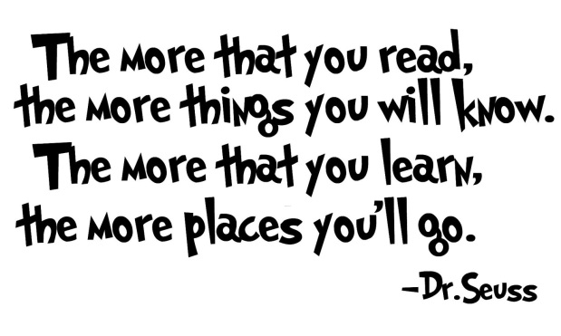

Key Stage 2

Why is reading so important?
At Wombwell Park Street Primary School, we believe that the skills gained from reading are invaluable. The opportunity for each child to leave our school equipped with the skills and strategies to support them in reading fluently, interpreting and processing written information is of paramount importance. We believe that reading underpins the broad curriculum that we offer, as all learners need to read in context, whether this be in Maths, Science, History or so on.
However, reading also extends beyond the parameters of our school; reading governs a significant amount of the world around us. It is therefore vital that, working in partnership with each other, staff, parents and carers of the children attending Wombwell Park Street Primary School, are provided with opportunities to develop and strengthen our children’s reading skills.
A recent report published by the Organisation for Economic Co-Operation and Development (OCED) found that approximately one in twenty adults in the United Kingdom possess the reading and writing skills of a five-year-old.
How will this guide enable me to support my child in reading?
At Park Street, we are committed to ensuring we support our students in becoming confident, independent readers who find pleasure in the process. Consequently, we have created this parent or carers guide with the aim of clearly conveying current Key Stage 2 expectations for reading, effective and appropriate questioning and ways to develop reading for pleasure.

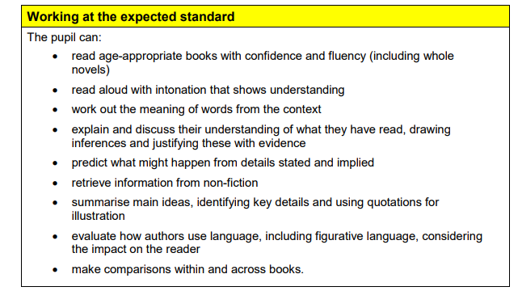
What is expected of our children by the end of Key Stage 2?
In order for our children to be working at the Age Related Expectation (ARE) at the end of Key Stage 2, the National Curriculum outlines that an individual must be able to demonstrate evidence of meeting ALL the statements listed below.

What are the key content domains of reading?
In order for our children to meet the current expectations in reading they need to demonstrate competency of the following skills:
Vocabulary
Inference
Prediction
Explanation
Retrieval
Summarising
To support your understanding of these terms, a series of sample questions are attached for each skill. To ensure your child has a sound understanding of a text it is beneficial to ask a series of questions that are derived from different content domains.

What is effective and appropriate questioning?
All too often one can assume that a child is a competent reader based on their ability to fluently and confidently read a text. That said, children may find the challenge of reading lies not in the decoding of words on a page, but instead fully understanding what they have read. Of course, this is something that as a school we continue to target through directed questioning, however we believe that forging links between these skills learned in school and then having the opportunity to further embed these at home is fundamental to supporting your child’s development . Below are a series of question prompts based on the content domains found in the National Curriculum Framework.

Prediction
From the cover what do you think this text is going to be about? What is happening now? What happened before this? What will /might happen after?
How might the character respond to the situation?
What makes you think this? Use evidence from the text
Do you think the choice of setting will influence how the plot develops?
What
Vocabulary
What does the word … suggest about the character/setting/mood?
Which word tells you that…? Which keyword tells you about the character/setting/mood?
Find and copy one word in the text which means……
Find and highlight the word that is closest in meaning to…
Find a word or phrase which shows/suggests that…
Inference
Find and copy a group of words which show that…
How might these words make the reader feel?
How does this paragraph suggest this?
How can you tell that…
What impression of … do you get from these paragraphs?
What was …. thinking when…
Who is telling the story?

Explanation
Why is the text arranged in this way?
What affect does … have on the reader?
Why might the mood of the character begin to change? Use the text as evidence.
What is the author’s point of view?
Which section would you say was the most interesting part? Why?
Summarising
Can you number these events 1-5 in the order that they happened? What happened after …?
What was the first thing that happened in the story?
Can you summarise in a sentence the opening/middle/end of the story?
What are the five most important points of the story so far?

Retrieval
What genre of text is this?
Where/when does the story take place?
What did she/he/it look like?
Who is the key character in the story?
Who had …
Give one example of…
What happened to…
How often did … occur?

How can I challenge my child’s thinking?
It is important that the questions we ask our children around their reading are a combination of low order thinking and higher order thinking questions. To support you in asking such questions is a HOTS grid. Asking questions which are higher up the grid’s structure are examples of questions which target higher order thinking.

Higher Order Thinking Questions
Might (Imagination)
Will
(Prediction)
Would
(Probability)
Can
(Possibility)
Did
(Past)
Is
(Present)
 | What  (Event) | When/Where  (Situation) | Which  (Choice) | Who  (Person) | Why  (Reason) | How  (Means)

What is reading for pleasure and why do we encourage it?
Think back to your favourite book as a child. What was it that made this book so enjoyable: was it read by someone important to you? Did the person bring the characters of the story to life simply through the animation of their voice? Now think about your favourite book as an adult. What is it about that book that made you fall in love with reading again?
Reading is such a personal thing that the answers to these questions will rarely be the same between people. However, what we strive to achieve at Wombwell Park Street Primary School, is a consistency for our children in their overall outlook on reading. As early as possible, we hope to inspire a love of reading in our children, a deep rooted appreciation and recognition of books as worlds just waiting to be opened and a chance for their mind to imagine beyond the constraints of reality.
How can I help my child read for pleasure?
- “Read something exciting!” Perhaps the most crucial element in reading for pleasure is allowing your child flexibility in what they want to read. Perhaps they are interested in comic books or maybe they prefer factual texts based on wildlife. What is certain, is that if the content interests them, they will more likely respond to questioning around the theme and want to engage in discussion.
- “Read with us!” Reading can be a challenge at home but why not develop traditions around reading? Build it into your evening routine with a hot chocolate and a biscuit to create a fantastic opportunity for quality 1:1 time.
- “Family Book Club!” Why not read the same book as your child and host family book club nights where you get to discuss what you thought of the latest chapter and share your genuine excitement at reading on to discover what happens next.
- “Make it fun!” Whilst reading a book, talk to the children about how it could be improved. Finding a book boring or the ending not as stimulating as you had hoped? Why not take it is turns telling each other alternative endings or storylines? Bored by a book cover? Design a new one that reflects the story you have read. Create a new character and add them to your story. Practice different voices for different characters,
- “Technology’s turn!” If your child particularly enjoys using technology why not incentivise reading through downloading an E-book on your tablet or device. This allows children to feel stimulated by the use of technology whilst still developing their interest in reading.

