Magic Triangle
Place the digits 1 to 9 into the circles so that each side of the triangle adds to the same total.
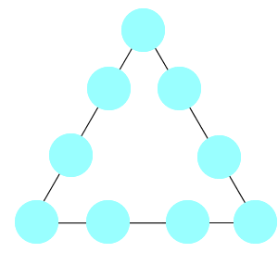
Can you find more than one solution?

How Much Did it Cost?

Dan bought a packet of crisps and an ice cream.
The cost of both of them together is in one of the boxes below.
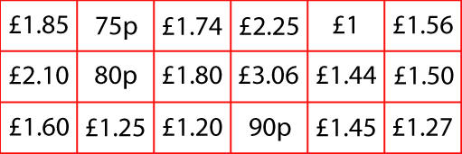
Use these clues to find out how much he paid:
1. You need more than three coins to make this amount.
2. There would be change when using most valuable coin to buy them.
3. The crisps cost more than 50p.
4. You could pay without using any copper coins.
5. The ice cream costs exactly twice as much as the crisps.

Finding Fifteen
Tim had nine cards, each with a different number from 1 to 9 on it.
He put the cards into three piles so that the total in each pile was 15.
How could he have done this?
Can you find all the different ways Tim could have done this?

