









Wombwell Park Street Primary School
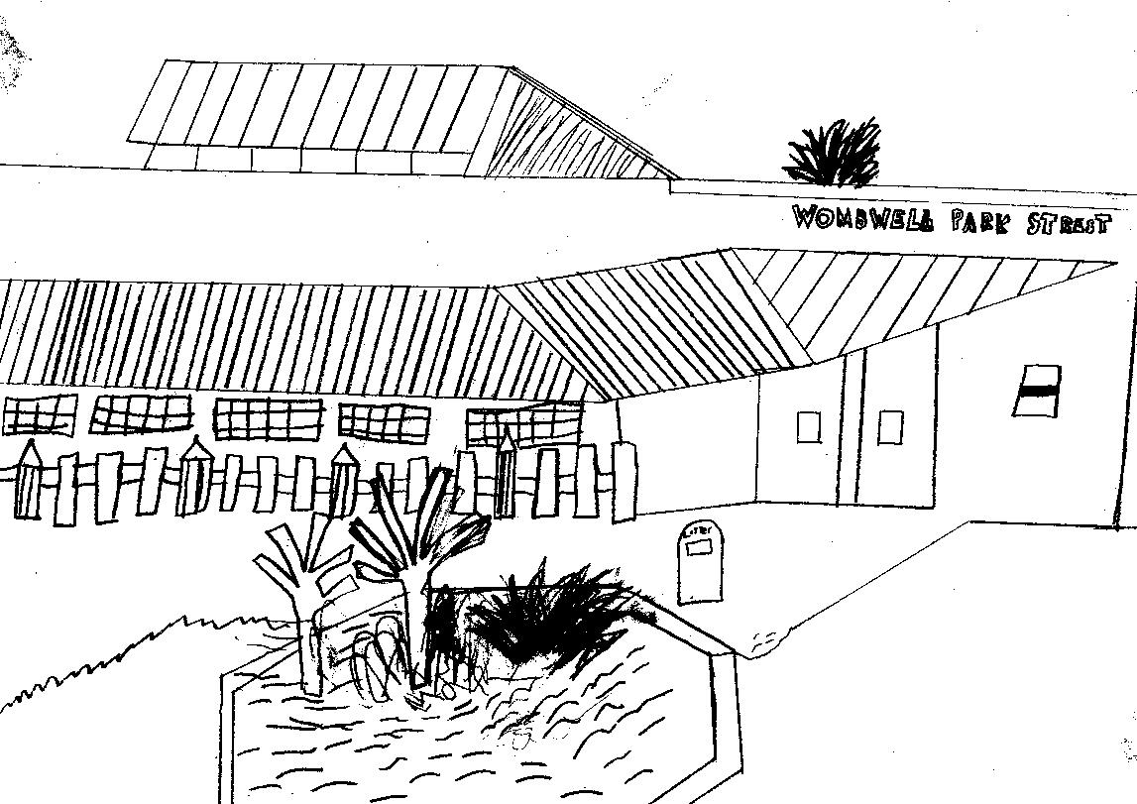
Park Street

Wombwell
Barnsley
S73 0HS
Tel: 01226 752029
Email: parkstreet@ecmtrust.co.uk
Website: www.wombwellparkstreet.co.uk

Executive Headteacher: Mrs G Foster-Wilson
Headteacher: Mrs C Lawson
Every Child Matters Academy Trust
Deputy Head: Mrs L Longden
Assistant Head: Mrs M Knott
________________________________________________________________________________________

Wednesday 10th January 2010

RE: Smartwatches in school

Dear Parent/ Carer,

Just recently we have had to deal with an issue in school regarding a Smartwatch and photos potentially being taken by the child wearing it. Fortunately, no photographs were taken in this case, however it did highlight to our Senior Leadership Team the potential safeguarding risk that this could bring, into a school setting.

We are therefore requesting that children do NOT wear a Smartwatch to school if it has the functionality to take photographs on it.

Parents / carers sign to say whether or not they allow their child to have a photograph taken in school when they are admitted to Park Street and whether they allow it to be used on the internet etc. Due to the modern day world, understandably, some parents do not want their child’s picture on the internet. Whilst staff are incredibly vigilant in terms of safeguarding, there are times in the day when children could potentially take photographs on such devices/ This could of course mean that these photos are then instantaneously synchronised to other devices (outside of school) and are at risk of being shared with unknown sources or published on the internet / social media eg via Bluetooth / 4G.

This is a huge safeguarding matter to us.

If you absolutely need children to wear their Smartphone to and from school, for whatever reason, then they need to be dropped off at the main school Office at the start of the day and collected at the end of the day (as they would a mobile phone). School policy is for the children to wear a small watch - not a camera. We have plenty of clocks, computers and mobile devices in school for the children to tell the time.

I thank you in anticipation of your support in this important matter.

Yours sincerely,

Mrs C Lawson
Headteacher

