

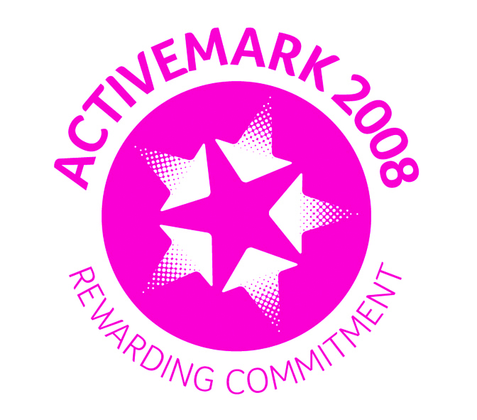

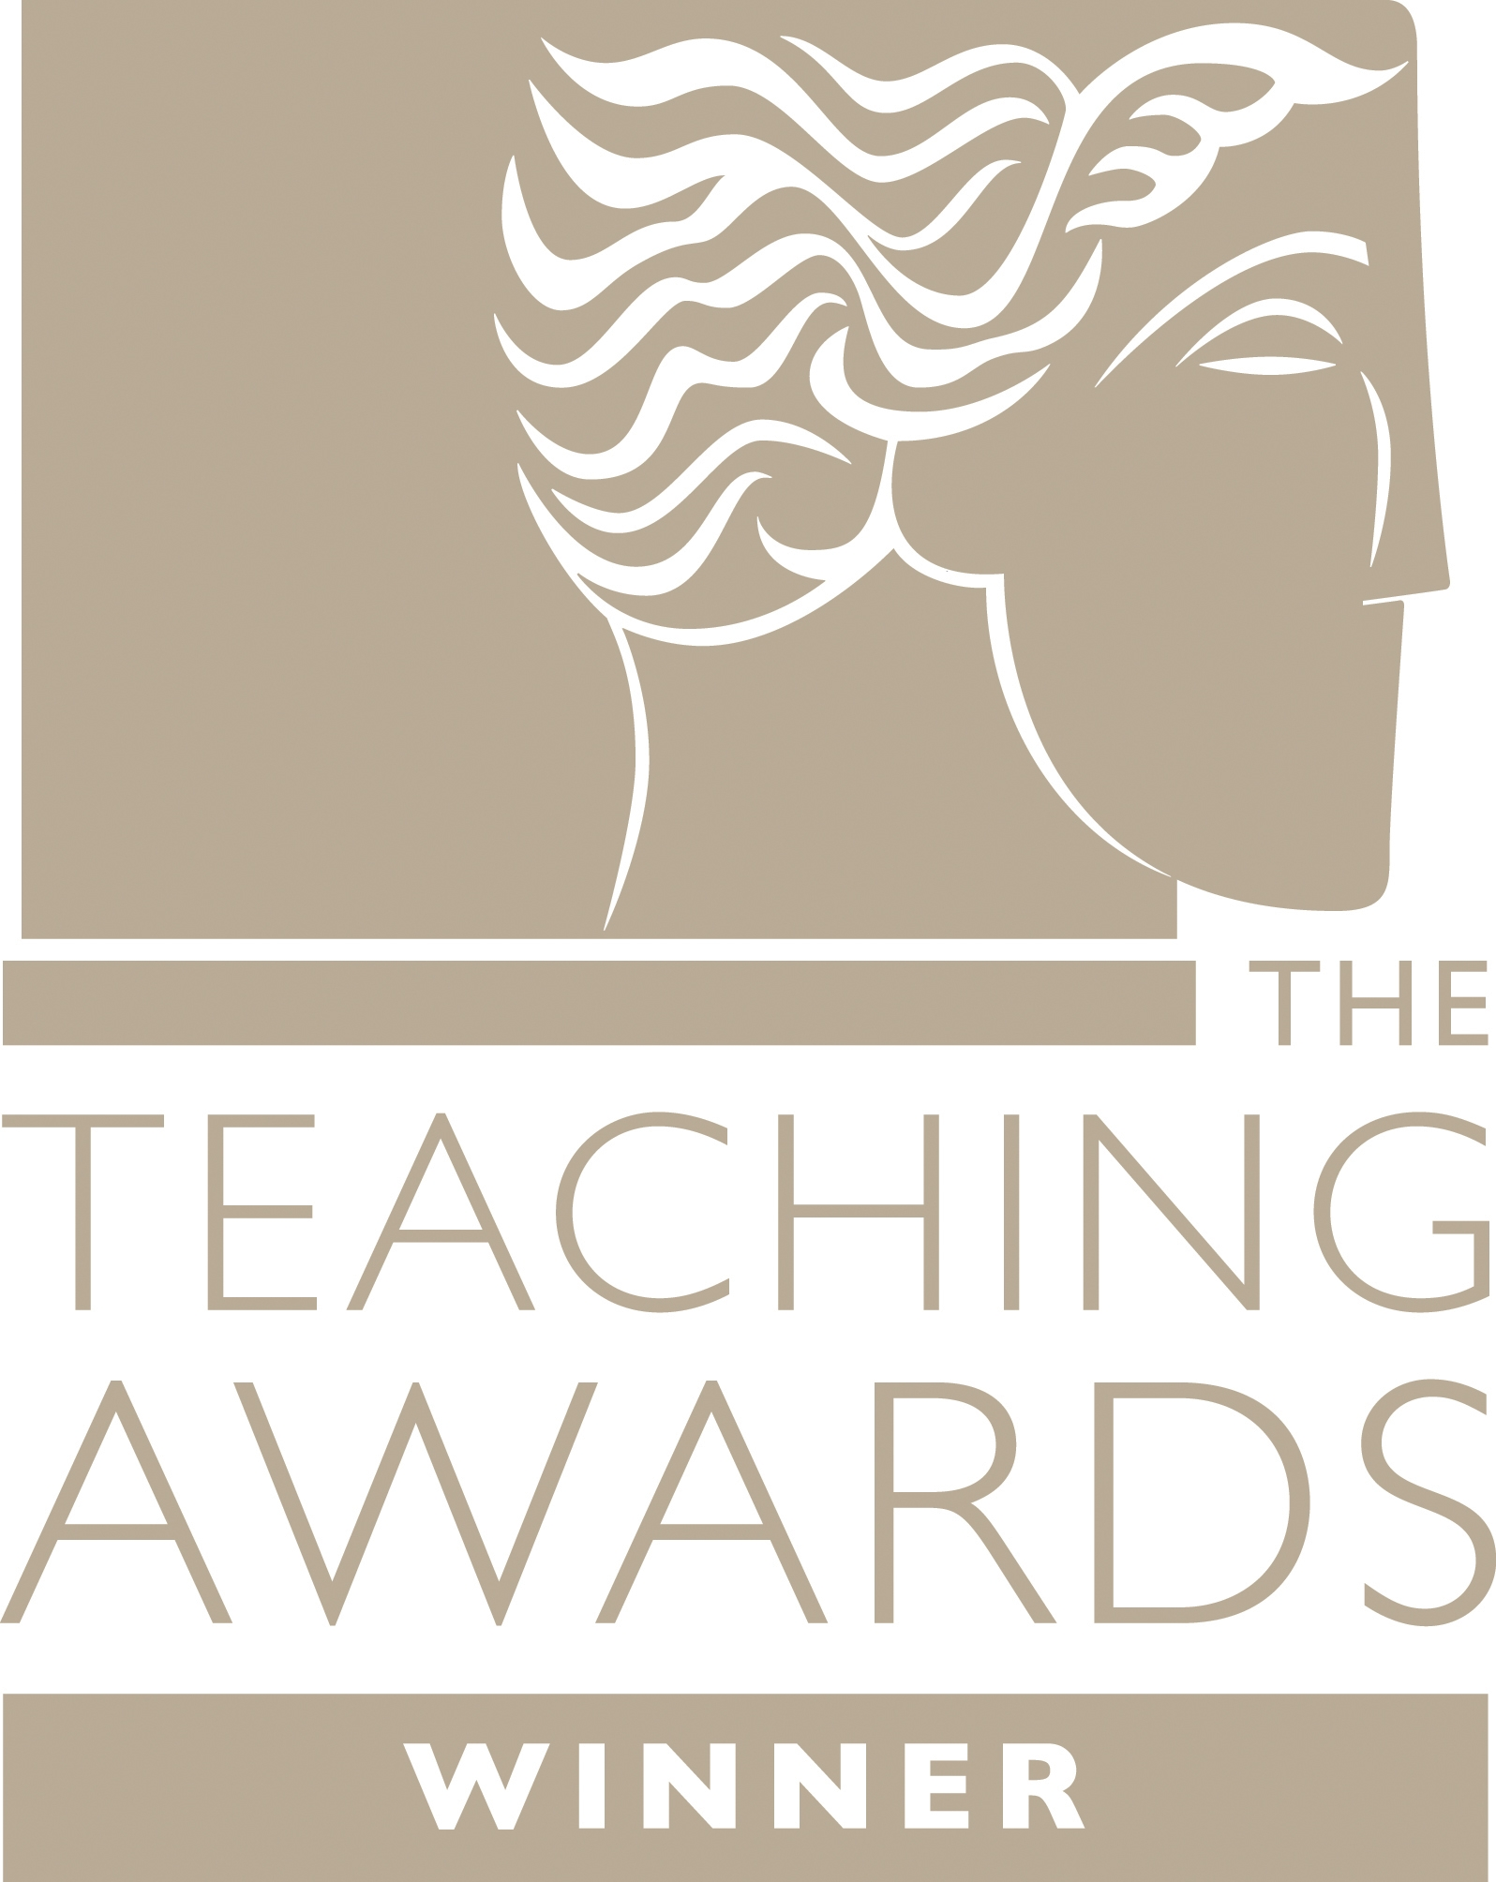





Wombwell Park Street Primary School
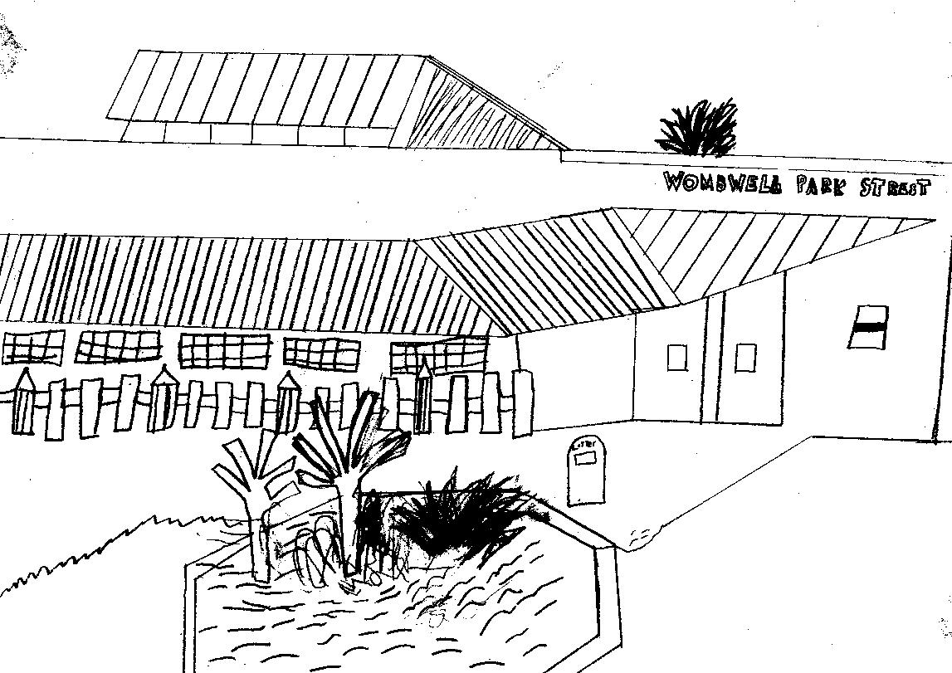
Park Street

Wombwell
Barnsley
S73 0HS
Tel: 01226 752029
Email: parkstreet@ecmtrust.co.uk
Website: www.wombwellparkstreetprimary.co.uk

Executive Headteacher: Mrs G Foster-Wilson
Head: Mrs C Lawson
Every Child Matters Academy Trust
Deputy Head: Mrs L Longden
Assistant Head: Mrs M Knott
________________________________________________________________________________________
8th May 2017
Re: Class 5 trip to Yorkshire Wildlife Park

Dear Parent/Carer

As part of our topic, we are planning a visit to Yorkshire Wildlife Park on Tuesday 6th June. This trip is to enhance the children’s learning of the habitats.

Information relating to the trip is as follows:-

We will depart from school promptly at 8.45am to enable us to arrive at The Wildlife Park by 9.45am. We will be leaving The Wildlife Park at 2.15pm and so should hopefully return by 3.15pm (depending on the traffic). We will notify school if there are any unexpected delays.

School uniform should be worn. The trip will be outside so please ensure that your child is suitably dressed.

A packed lunch will be required. Grab a bag lunches can be ordered from school at the usual cost of £1.90. Payment for this should be made in the usual way via the school gateway app. Children who qualify for free school meals should order their meal in the usual way.

A voluntary contribution of £12.50 per child is requested to cover the cost of the visit. This amount will cover the cost of the coach as well as the entry fee and an educational session. To help with the cost of the trip, school has made a contribution to subsidise this. Unfortunately if insufficient contributions are received then the visit will have to be cancelled.

If you would like your child to take part in the visit, would you please complete the slip below or alternatively visit www.schoolgateway.com for this.

Please ensure payment, your consent and lunch details are received by no later than Thursday 25th May.

Yours sincerely

Miss Garrett
-----------------------------------------------------------------------------------------------------------------------------------------------------------------
Wombwell Park Street Primary School – Class 5 visit to Yorkshire Wildlife Park 6th June 2017

I give permission for my child………………………………Class 5 to attend Yorkshire Wildlife Park on 6th June 2017

I enclose £12.50 for the trip ( )

My child would like sandwiches from home ( )
My child would like a grab a bag from school – Cheese ( ) Ham ( ) Tuna ( ) Bread/butter ( ) Chicken ( )

Reliable emergency contact number for the day: Name …………………………… Tel Number ………………………….
Details of any medical conditions we should be aware of ………………………………………………………………….……..

Signature of Parent……………………………………………………… Date……………………………

